**Plaice (*Pleuronectes platessa*) in Division 7.d (eastern English Channel)**

ICES advice on fishing opportunities

ICES advises that when the MSY approach is applied, catches in 2023 should be no more than 4738 tonnes.

Management of plaice in Divisions 7.d and 7.e under a combined area TAC prevents effective control of the single‑species exploitation rates and could lead to the overexploitation of either species. ICES advises that management should be implemented at the stock area level.

ICES notes the existence of a precautionary management plan, developed and adopted by one of the relevant management authorities for this stock.

**Stock development over time**

Fishing pressure on the stock is above FMSY but below Fpa and Flim, and spawning-stock size is above MSY Btrigger, Bpa, and Blim.

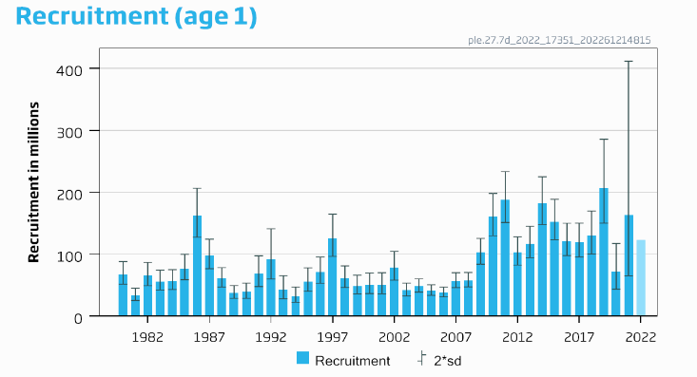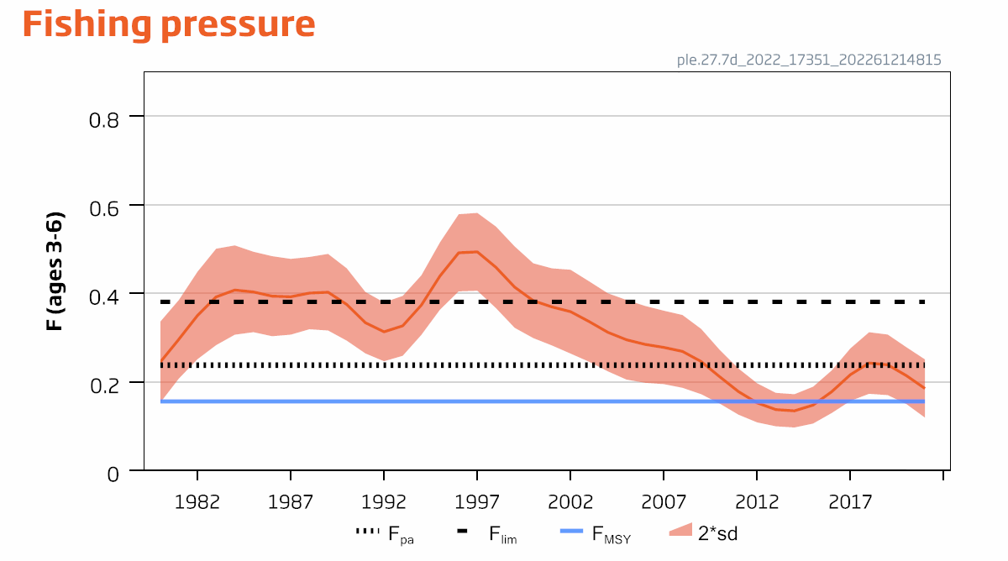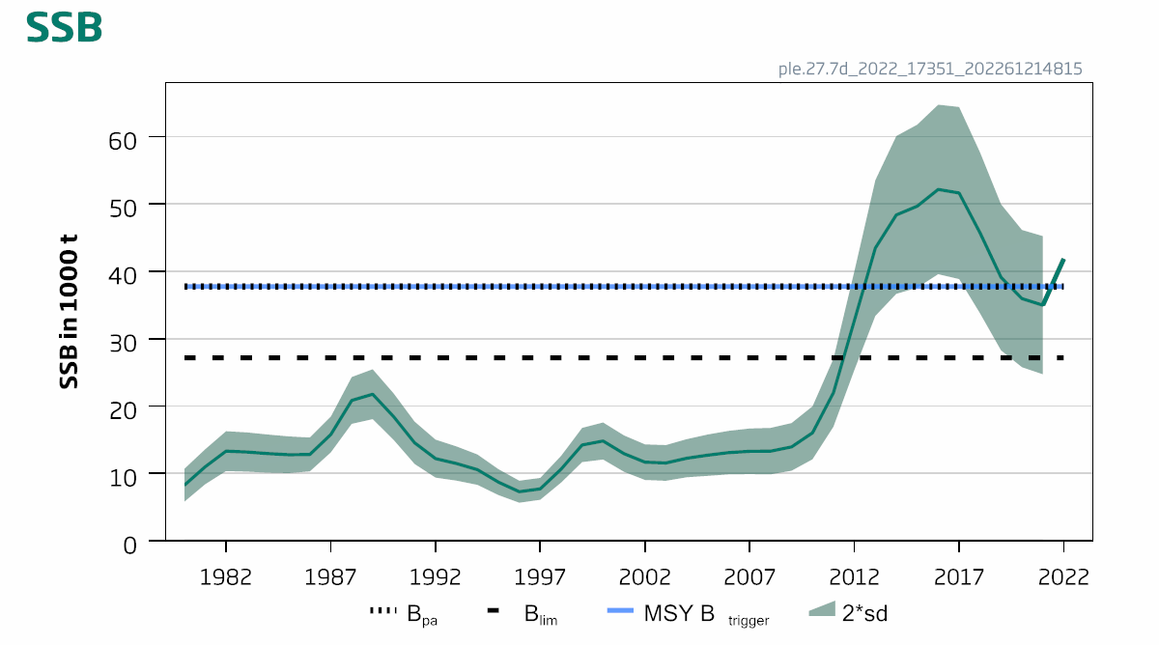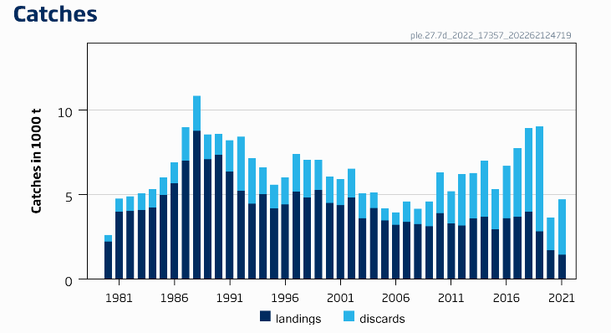

**Figure 1** Plaice in Division 7.d. Summary of the stock assessment. The assumed recruitment value for 2022 is shaded in a lighter colour. Discard data are only available since 2006; values prior to that are model estimates.

Catch scenarios

**Table 1** Plaice in Division 7.d. Values in the forecast and for the interim year for Division 7.d plaice stock only.

| Variable | Value | Notes |
| --- | --- | --- |
| Fages 3–6 (2022) | 0.21 | Fsq = Faverage 2019–2021 |
| SSB (2023) | 41 642 | Short-term forecast (STF); in tonnes |
| Rage 1 (2022–2023) | 122 963 | Geometric mean 2016–2020; in thousands |
| Total catch (2022) | 5392 | STF; in tonnes |
| Projected landings (2022) | 2385 | STF; assuming average landings ratio (2019–2021); in tonnes |
| Projected discards (2022) | 3007 | STF; assuming average discards ratio (2019–2021); in tonnes |

**Table 2** Plaice in Division 7.d. Annual catch scenarios. All weights are in tonnes.

| Basis | Division 7.d plaice stock | | | | | | | | | All plaice in Division 7.d# | | | | |
| --- | --- | --- | --- | --- | --- | --- | --- | --- | --- | --- | --- | --- | --- | --- |
| Total catch (2023)^ | Projected landings (2023) | Projected discards * (2023) | Ftotal  (ages 3−6) (2023) | Fprojected landings  (ages 3–6) (2023) | Fprojected discards  (ages 3–6) (2023) | SSB  (2024) | % SSB change  ** | % advice change$ | Total catch (2023) | Projected landings (2023) | Projected discards* (2023) | % change in projected catches^^ | % advice change## |
| ICES advice basis | | | | | | | | | | | | | | |
| MSY approach: FMSY | 4738 | 2204 | 2534 | 0.156 | 0.046 | 0.110 | 44 175 | 6.08 | −25 | 5671 | 2638 | 3033 | 4.20 | −25 |
| Other scenarios | | | | | | | | | | | | | | |
| F = FMSY lower | 3493 | 1627 | 1866 | 0.113 | 0.034 | 0.079 | 45 820 | 10 | −45 | 4181 | 1948 | 2233 | −23 | −45 |
| F = FMSY | 4738 | 2204 | 2534 | 0.156 | 0.046 | 0.110 | 44 175 | 6.08 | −25 | 5671 | 2638 | 3033 | 4.20 | −25 |
| F = FMSY upper | 6618 | 3070 | 3548 | 0.22 | 0.067 | 0.157 | 41 706 | 0.15 | 4.00 | 7922 | 3674 | 4247 | 46 | 4.70 |
| F = 0 | 0 | 0 | 0 | 0 | 0 | 0 | 50 473 | 23 | −100 | 0 | 0 | 0 | −100 | −100 |
| Fpa | 6992 | 3506 | 3750 | 0.23 | 0.07 | 0.17 | 41 217 | −1.02 | 9.80 | 8370 | 3880 | 4990 | 54 | 10 |
| Flim | 10 578 | 4876 | 5702 | 0.38 | 0.27 | 0.11 | 36 573 | −12 | 66 | 12 661 | 5836 | 6826 | 133 | 67 |
| SSB (2024) = Blim | 18 080 | 8210 | 9870 | 0.75 | 0.22 | 0.53 | 27 147 | −35 | 184 | 21 642 | 9827 | 11 814 | 298 | 186 |
| SSB (2024) = Bpa | 9655 | 4457 | 5198 | 0.34 | 0.10 | 0.24 | 37 761 | −9.32 | 52 | 11 555 | 5335 | 6222 | 112 | 53 |
| SSB (2024) = MSY Btrigger | 9655 | 4457 | 5198 | 0.34 | 0.10 | 0.24 | 37 761 | −9.32 | 52 | 11 555 | 5335 | 6222 | 112 | 53 |
| F = F2022 | 5556 | 2581 | 2975 | 0.185 | 0.06 | 0.130 | 43 098 | 3.50 | −13 | 6651 | 3090 | 3561 | 22 | −12 |

* Including BMS landings, assuming recent discard rate.

** SSB 2024 relative to SSB 2023.

$ Total catch of plaice stock in 2023 relative to the advice value 2022 (6365 tonnes)

^ Differences between total catch and the sum of projected landings and discards result from rounding.

^^ Total catch of plaice in division 7d in 2023 relative to the ICES estimates of catches in 2021 (5442 tonnes)

# All plaice in Division 7.d, including plaice originating from the North Sea and the western English Channel, according to a ratio calculated over the years 2003–2021: 16.46 % of the plaice landed in Division 7.d is assumed to originate from the North Sea and the western English Channel which is equivalent to an additional 19.70% on top of the landings from the Division 7.d plaice stock. This ratio is therefore added to the predicted values for the Division 7.d plaice stock and applies to total catch, projected landings, and projected discards.

## Total catch of plaice in division 7d in 2023 relative to the advice value 2022 (7566 tonnes)

The advice change (−25% for the Division 7.d plaice stock) is the result of a revision of reference points.

Basis of the advice

**Table 3** Plaice in Division 7.d. The basis of the advice.

|  |  |
| --- | --- |
| Advice basis | MSY approach |
| Management plan | ICES is aware of the multiannual management plan (MAP) which has been adopted by the EU for this stock (EU, 2018) and which ICES considers to be precautionary. There is no agreed shared management plan with UK for this stock, and ICES provides advice according to ICES MSY approach. Catch scenarios consistent with the MAP FMSY ranges are provided. |

Quality of the assessment

There is uncertainty about catches of the Division 7.d plaice stock because of migrations between 7.d and the North Sea and the western English Channel during the spawning period. The current assessment results are dependent on the proportion of quarter 1 removals estimated from an historical tagging survey (ICES, 2010).

A new FR CGFS index is used in 2022 assessment to fix the reported issues in 2021 assessment (ICES, 2021). The update of reference points, based on the latest selectivity and biological patterns, resulted in a substantial decrease of FMSY due to decreasing trends in the stock weight at age in the recent years.

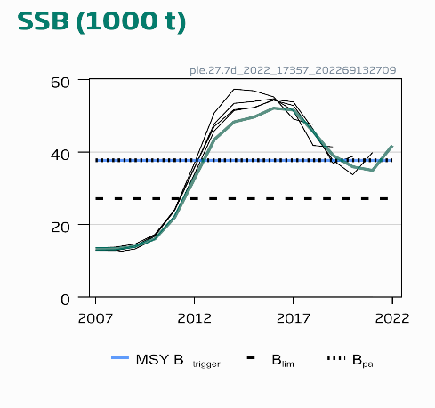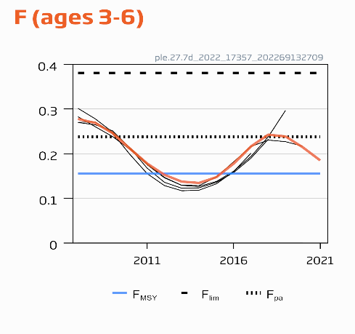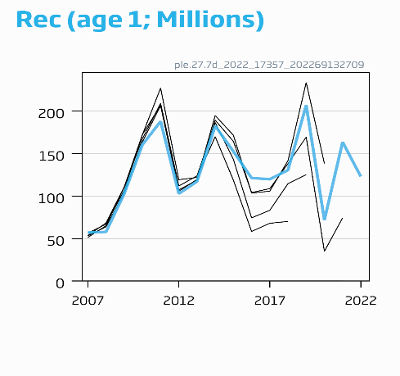

**Figure 2** Plaice in Division 7.d. Historical assessment results (final-year recruitment included for each line, corresponding to the forecast recruitment in the interim year). The reference points were revised in 2022, and only assessment results from the final year should be compared to the reference points indicated.

Issues relevant for the advice

A single TAC covers both divisions 7.d and 7.e; management should ensure that fishing opportunities are in line with the stock status for each of the stocks in the combined management area to ensure that both stocks are exploited sustainably.

A catch advice of 4738 tonnes corresponds to catches of plaice in Division 7.d of no more than 5671 tonnes in 2023, assuming the same proportion of the Division 7.e and Subarea 4 plaice stocks is taken in Division 7.d as was estimated during 2003–2021. Management should be implemented at the stock level.

Plaice is caught in a mixed fishery targeting sole, with 80 mm mesh size. This leads to a large number of plaice being discarded because this mesh size is not matched to the minimum conservation reference size (MCRS).

Decreasing trends in observed mean weight at age could be explained by a change in the catchability and need to be investigated.

Reference points

**Table 4** Plaice in Division 7.d. Reference points, values, and their technical basis.

| Framework | Reference point | Value | Technical basis | Source |
| --- | --- | --- | --- | --- |
| MSY approach | MSY Btrigger | 37 761 | Bpa; in tonnes | ICES (2022a) |
| FMSY | 0.156 | EQsim analysis based on recruitment period 1980–2020 | ICES (2022a) |
| Precautionary approach | Blim | 27 174 | Break-point of hockey stick stock–recruit relationship, based on recruitment period 1980–2020; in tonnes | ICES (2022a) |
| Bpa | 37 761 | Blim × exp (1.645 × 𝜎) ≈ 1.4 × Blim , 𝜎 = 0.20; in tonnes | ICES (2022a) |
| Flim | 0.381 | EQsim analysis based on recruitment period 1980–2020 | ICES (2022a) |
| Fpa | 0.238 | The F that provides a 95% probability for SSB to be above Blim (Fp.05 with advice rule [AR]) | ICES (2022a) |
| EU Management plan (MAP)* | MAP MSY Btrigger | 37 761 | MSY Btrigger; in tonnes | ICES (2022a) |
| MAP Blim | 27 174 | Blim; in tonnes | ICES (2022a) |
| MAP FMSY | 0.156 | FMSY | ICES (2022a) |
| MAP range Flower | 0.113 | Consistent with ranges resulting in no more than 5% reduction in long-term yield compared with MSY | ICES (2022a) |
| MAP range Fupper | 0.224 | Consistent with ranges resulting in no more than 5% reduction in long-term yield compared with MSY | ICES (2022a) |

* EU multiannual plan (MAP) for the Western Waters (EU, 2019).

Basis of the assessment

**Table 5** Plaice in Division 7.d. Basis of the assessment and advice.

|  |  |
| --- | --- |
| ICES stock data category | 1 ([ICES, 2022b](https://doi.org/10.17895/ices.advice.19928060)) |
| Assessment type | Age-based analytical assessment (Aarts and Poos, 2009) that uses catches in the model and in the forecast (ICES, 2022a) |
| Input data | Commercial catch (international landings, with age frequencies from catch sampling covering 75% of the landings), two survey indices UK-BTS [B2453]. A delta-GAM is used to calculate FR-GFS index [G3425]. Time invariant natural mortality by age is calculated from Peterson and Wroblewski (1984). Fixed maturity ogive is based on biological sampling. |
| Discards and bycatch | Discards are included in the assessment and all major fleets are covered. In 2021, 60% of the landings had associated discard information, with age frequencies from catch sampling covering 57% of the discards. Fifty eight percent of the discard estimates are based on observations. The model reconstructs discards for years where data are not available (before 2006). |
| Indicators | None |
| Other information | Last benchmarked in 2015 (WKPLE; ICES, 2015), Reference points updated in 2022 (WGNSSK; ICES, 2022a) |
| Working group | Working Group on the Assessment of Demersal Stocks in the North Sea and Skagerrak ([WGNSSK](http://www.ices.dk/community/groups/Pages/WGNSSK.aspx)) |

**History of the advice, catch, and management**

**Table 6** Plaice in Division 7.d. History of ICES advice, official landings for plaice in Division 7.d, agreed TAC for divisions 7.d and 7.e, and ICES estimates for landings and discards of Division 7.d plaice and for plaice in Division 7.d. All weights are in tonnes.

| Year | ICES advice | Landings corresponding to advice | | | Catch corresponding to advice | | Agreed TAC  7.d, e | Official landings of plaice in 7.d * | ICES landings of plaice in 7.d* | ICES landings 7.d plaice | ICES discards of 7.d plaice | ICES discards of plaice in 7.d ^^ |
| --- | --- | --- | --- | --- | --- | --- | --- | --- | --- | --- | --- | --- |
| 7.d plaice | Plaice in 7.d | Plaice in 7.d, e | 7.d plaice stock | Plaice in 7.d |
| 1987 | Precautionary TAC for 7.d, e |  |  | 6800 |  |  | 8300 | 7867 | 8366 | 7006 |  |  |
| 1988 | Precautionary TAC for 7.d, e |  |  | 6900 |  |  | 9960 | 9103 | 10 420 | 8785 |  |  |
| 1989 | No increase in effort for 7.d, e |  |  | 11 700 |  |  | 11 700 | 7115 | 8758 | 7093 |  |  |
| 1990 | No increase in F; TAC for 7.d, e |  |  | 10 700 |  |  | 10 700 | 8367 | 9047 | 7349 |  |  |
| 1991 | TAC for 7.d, e |  |  | 8800 |  |  | 10 700 | 7913 | 7813 | 6362 |  |  |
| 1992 | *Status quo* F gives mean SSB |  | 7600 |  |  |  | 9600 | 6232 | 6337 | 5219 |  |  |
| 1993 | *Status quo* F within safe biological limits |  | 6400 |  |  |  | 8500 | 4771 | 5331 | 4479 |  |  |
| 1994 | No long-term gains in increased F |  | - |  |  |  | 9100 | 5633 | 6121 | 5047 |  |  |
| 1995 | No increase in F |  | 5600 |  |  |  | 8000 | 4569 | 5130 | 4196 |  |  |
| 1996 | No long-term gains in increasing F |  | 6500 |  |  |  | 7530 | 4598 | 5393 | 4430 |  |  |
| 1997 | No advice |  | - |  |  |  | 7090 | 5316 | 6307 | 5180 |  |  |
| 1998 | Reduce F in 1998 by 30% from 1996 value |  | 4300 |  |  |  | 5700 | 4830 | 5762 | 4831 |  |  |
| 1999 | Fishing at Fpa |  | 6300 |  |  |  | 7400 | 5437 | 6326 | 5268 |  |  |
| 2000 | Fishing at Fpa |  | 4900 |  |  |  | 6500 | 5235 | 6014 | 4521 |  |  |
| 2001 | Fishing at < Fpa |  | < 4400 |  |  |  | 6000 | 4968 | 5266 | 4380 |  |  |
| 2002 | Fishing at < Fpa |  | < 5800 |  |  |  | 6700 | 5496 | 5777 | 4846 |  |  |
| 2003 | Fishing at < Fpa |  | < 5300 |  |  |  | 5970 | 4650 | 4086 | 3610 |  |  |
| 2004 | Fishing at < Fpa ** |  | < 5400 |  |  |  | 6060 | 4312 | 4750 | 4206 |  |  |
| 2005 | Fishing at < Fpa ** |  | < 4400 |  |  |  | 5150 | 3706 | 3991 | 3485 |  |  |
| 2006 | No effort increase ** |  |  |  |  |  | 5151 | 3525 | 3646 | 3225 | 727 | 749 |
| 2007 | Average landings ** |  | < 4000 |  |  |  | 5050 | 3845 | 4001 | 3381 | 1220 | 1252 |
| 2008 | Average landings ** |  | < 3500 |  |  |  | 5050 | 3609 | 3864 | 3278 | 888 | 936 |
| 2009 | Average landings (2006–2008) ** |  | < 3500 |  |  |  | 4646 | 3522 | 3560 | 3124 | 1473 | 1528 |
| 2010 | Average landings (2007–2009) |  | < 3500 |  |  |  | 4274 | 3892 | 4411 | 3910 | 2412 | 2511 |
| 2011 | Average landings (2008–2010) |  | < 3500 |  |  |  | 4665 | 3593 | 3649 | 3291 | 1926 | 2024 |
| 2012 | No increase in catches and reduce discards |  | - |  |  |  | 5062 | 3611 | 3723 | 3178 | 3043 | 3336 |
| 2013 | Transition to FMSY proxy for data‑limited stocks by 2015 and reduce discards |  | < 4300 |  |  |  | 6400 | 4182 | 4127 | 3604 | 2696 | 2955 |
| 2014 | Transition to FMSY proxy for data‑limited stocks by 2015 and reduce discards | < 3016 | < 3925 |  |  |  | 5322 | 4326 | 4320 | 3675 | 3325 | 3886 |
| 2015 | ICES DLS approach (FMSY proxy) | < 2811 | < 3469 |  |  |  | 6223 | 3749 | 3727 | 2957 | 2368 | 2821 |
| 2016 | MSY approach | ≤ 10 855 | ≤ 12 512 | ≤ 16 249 | ≤ 16 923 | ≤ 19 506 | 12 446 | 4658 | 4638 | 3617 | 3090 | 3603 |
| 2017 | MSY approach | ≤ 7550 | ≤ 8764 | ≤ 11 381 | ≤ 12 805 | ≤ 14 864 | 10 022 | 4581 | 4613 | 3689 | 4075 | 5065 |
| 2018 | MSY approach | ≤ 7132 | ≤ 8335 | ≤ 10 909 | ≤ 10 592 | ≤ 12 378 | 10 360 | 4977 | 4999 | 3975 | 4959 | 6215 |
| 2019 | MSY approach |  |  |  | ≤ 7864 | ≤ 9225 | 10 354 | 3681 | 3721 | 2836 | 6211 | 7064 |
| 2020 | Management Plan^ |  |  |  | 9073 (range 6545–12 029) | 10 687 (range 7710–14 170) | 9154 | 2120 | 2152 | 1727 | 1902 | 2191 |
| 2021 | Management Plan^ |  |  |  | 8402 (range 6066–11 130) | 9959 (range 7190–13 192) | 11 920 | 1774 | 1770 | 1456 | 3261 | 3672 |
| 2022 | MSY approach |  |  |  | ≤ 6365 | ≤ 7566 | 9138 |  |  |  |  |  |
| 2023 | MSY approach |  |  |  | ≤ 4738 | ≤ 5671 |  |  |  |  |  |  |

* Plaice in Division 7.d, taking into account fish caught in the first quarter in Division 7.d that come to spawn from Division 7.e and Subarea 4.

** Single-stock boundary and the exploitation of this stock should be conducted in the context of mixed fisheries.

^ EU multiannual plan (MAP) for the Western Waters (EU, 2019).

^^ Including BMS landings.

**History of the catch and landings**

**Table 7** Plaice in Division 7.d. Catch distribution of plaice in 7.d by fleet in 2021 as estimated by ICES.

|  |  |  |  |  |  |
| --- | --- | --- | --- | --- | --- |
| Catch | Landings | | | | Discards |
| 5442 tonnes | Beam trawl  39 % | Otter trawl 39 % | Trammel nets 10 % | Other gears 11 % | 3672 tonnes |
| 1770 tonnes | | | |

**Table 8** Plaice in Division 7.d. History of commercial catch and landings; both the official and ICES estimated values are presented by area for each country participating in the fishery. All weights are in tonnes.

| Year | Belgium | France | UK(E+W) | Others | Official landings in 7.d | BMS landings | Unallocated in 7.d | ICES estimated landings of plaice in 7.d | Quarter 1 removals^ | ICES estimated landings for 7.d plaice^ | ICES estimated landings for plaice in 7.e | Agreed TAC for 7.d, e* |
| --- | --- | --- | --- | --- | --- | --- | --- | --- | --- | --- | --- | --- |
| 1976 | 147 | 1 439 | 376 |  | 1 962 |  | 1 | 1 963 |  | 1 963 | 640 |  |
| 1977 | 149 | 1 714 | 302 |  | 2 165 |  | 81 | 2 246 |  | 2 246 | 702 |  |
| 1978 | 161 | 1 810 | 349 |  | 2 320 |  | 156 | 2 476 |  | 2 476 | 784 |  |
| 1979 | 217 | 2 094 | 278 |  | 2 589 |  | 28 | 2 617 |  | 2 617 | 977 |  |
| 1980 | 435 | 2 905 | 304 |  | 3 644 |  | −994 | 2 650 | 427 | 2 223 | 1 178 |  |
| 1981 | 815 | 3 431 | 489 |  | 4 735 |  | 34 | 4 769 | 760 | 4 009 | 1 676 |  |
| 1982 | 738 | 3 504 | 541 | 22 | 4 805 |  | 60 | 4 865 | 825 | 4 040 | 1 878 |  |
| 1983 | 1 013 | 3 119 | 548 |  | 4 680 |  | 363 | 5 043 | 950 | 4 093 | 1 714 |  |
| 1984 | 947 | 2 844 | 640 |  | 4 431 |  | 730 | 5 161 | 912 | 4 249 | 1 758 |  |
| 1985 | 1 148 | 3 943 | 866 |  | 5 957 |  | 65 | 6 022 | 1 022 | 5 000 | 1 677 |  |
| 1986 | 1 158 | 3 288 | 828 |  | 5 274 |  | 1 560 | 6 834 | 1 161 | 5 673 | 2 078 |  |
| 1987 | 1 807 | 4 768 | 1 292 |  | 7 867 |  | 499 | 8 366 | 1 360 | 7 006 | 2 272 | 8 300 |
| 1988 | 2 165 | 5 688 | 1 250 |  | 9 103 |  | 1 317 | 10 420 | 1 635 | 8 785 | 2 835 | 9 960 |
| 1989 | 2 019 | 3 713 | 1 383 |  | 7 115 |  | 1 643 | 8 758 | 1 665 | 7 093 | 2 742 | 11 700 |
| 1990 | 2 149 | 4 739 | 1 479 |  | 8 367 |  | 680 | 9 047 | 1 698 | 7 349 | 2 985 | 10 700 |
| 1991 | 2 265 | 4 082 | 1 566 |  | 7 913 |  | −100 | 7 813 | 1 451 | 6 362 | 2 183 | 10 700 |
| 1992 | 1 560 | 3 099 | 1 572 | 1 | 6 232 |  | 105 | 6 337 | 1 118 | 5 219 | 1 882 | 9 600 |
| 1993 | 877 | 2 792 | 1 102 |  | 4 771 |  | 560 | 5 331 | 852 | 4 479 | 1 614 | 8 500 |
| 1994 | 1 418 | 3 199 | 1 007 | 9 | 5 633 |  | 488 | 6 121 | 1 074 | 5 047 | 1 404 | 9 100 |
| 1995 | 1 157 | 2 598 | 814 |  | 4 569 |  | 561 | 5 130 | 934 | 4 196 | 1 247 | 8 000 |
| 1996 | 1 112 | 2 630 | 856 |  | 4 598 |  | 795 | 5 393 | 963 | 4 430 | 1 266 | 7 530 |
| 1997 | 1 161 | 3 077 | 1 078 |  | 5 316 |  | 991 | 6 307 | 1 127 | 5 180 | 1 583 | 7 090 |
| 1998 | 854 | 3 276 | 700 |  | 4 830 |  | 932 | 5 762 | 931 | 4 831 | 1 346 | 5 700 |
| 1999 | 1 306 | 3 388 | 743 |  | 5 437 |  | 889 | 6 326 | 1 058 | 5 268 | 1 543 | 7 400 |
| 2000 | 1 298 | 3 183 | 754 |  | 5 235 |  | 779 | 6 014 | 1 494 | 4 521 | 1 625 | 6 500 |
| 2001 | 1 346 | 2 962 | 660 |  | 4 968 |  | 298 | 5 266 | 886 | 4 380 | 1 310 | 6 000 |
| 2002 | 1 204 | 3 450 | 841 | 1 | 5 496 |  | 281 | 5 777 | 931 | 4 846 | 1 472 | 6 700 |
| 2003 | 998 | 2 893 | 756 | 3 | 4 650 |  | −564 | 4 086 | 476 | 3 610 | 1 387 | 5 970 |
| 2004 | 954 | 2 766 | 582 | 10 | 4 312 |  | 438 | 4 750 | 544 | 4 206 | 1 337 | 6 060 |
| 2005 | 832 | 2 432 | 421 | 21 | 3 706 |  | 285 | 3 991 | 506 | 3 485 | 1 319 | 5 150 |
| 2006 | 1 024 | 1 935 | 550 | 16 | 3 525 |  | 121 | 3 646 | 421 | 3 225 | 1 411 | 5 151 |
| 2007 | 1 355 | 2 017 | 463 | 10 | 3 845 |  | 156 | 4 001 | 620 | 3 381 | 1 146 | 5 050 |
| 2008 | 1 386 | 1 740 | 471 | 12 | 3 609 |  | 255 | 3 864 | 586 | 3 278 | 1 112 | 5 050 |
| 2009 | 1 002 | 1 892 | 612 | 16 | 3 522 |  | 38 | 3 560 | 436 | 3 124 | 1 024 | 4 646 |
| 2010 | 1 123 | 2 190 | 517 | 62 | 3 892 |  | 519 | 4 411 | 501 | 3 910 | 1 208 | 4 274 |
| 2011 | 1 067 | 1 994 | 472 | 60 | 3 593 |  | 56 | 3 649 | 358 | 3 291 | 1 417 | 4 665 |
| 2012 | 1 045 | 1 962 | 542 | 63 | 3 612 |  | 111 | 3 723 | 544 | 3 178 | 1 492 | 5 062 |
| 2013 | 1 295 | 2 159 | 641 | 87 | 4 182 |  | −55 | 4 127 | 523 | 3 604 | 1 472 | 6 400 |
| 2014 | 1 389 | 2 229 | 633 | 76 | 4 327 |  | −7 | 4 320 | 645 | 3 675 | 1 490 | 5 322 |
| 2015 | 1 600 | 1 702 | 392 | 54 | 3 748 |  | −21 | 3 727 | 770 | 2 957 | 1 424 | 6 223 |
| 2016 | 2 247 | 1 557 | 795 | 60 | 4 659 |  | −21 | 4 638 | 1 020 | 3 617 | 2 013 | 12 446 |
| 2017 | 2 189 | 1 487 | 814 | 86 | 4 576 |  | 37 | 4 613 | 924 | 3 689 | 2 128 | 10 022 |
| 2018 | 1 876 | 2 171 | 832 | 98 | 4 977 |  | 27 | 4 999 | 1 024 | 3 975 | 1 880 | 10 360 |
| 2019 | 1 277 | 1 688 | 628 | 87 | 3 681 | <1 | 40 | 3 721 | 885 | 2 836 | 1 725 | 10 354 |
| 2020 | 745 | 984 | 342 | 50 | 2 120 | <1 | 32 | 2 152 | 424 | 1 727 | 1 373 | 9 154 |
| 2021 | 663 | 769 | 284 | 53 | 1 774 | <1 | - 4 | 1 770 | 313 | 1 456 |  | 11 920 |

* TACs for divisions 7.d and 7.e.

^ Takes into account the ‘quarter 1 removal’ of 65% of the quarter 1 Division 7.d landings of plaice that originate from Division 7.e and Subarea 4.

Summary of the assessment

**Table 9** Plaice in Division 7.d. Assessment summary. Recruitment in thousands. Weights are in tonnes. High and low correspond to 2 standard deviation.

|  |  |  |  |  |  |  |  |  |  |  |  |  |
| --- | --- | --- | --- | --- | --- | --- | --- | --- | --- | --- | --- | --- |
| Year | Recruitment (Age 1) | | | Spawning-stock biomass | | | Landings | Discards* | Catch* | Fishing pressure (Ages 3–6) | | |
| R | High | Low | SSB | High | Low | F | High | Low |
| 1980 | 67 465 | 88 163 | 51 589 | 8 247 | 10 694 | 5 800 | 2 223 | 410 | 2 223 | 0.24 | 0.34 | 0.153 |
| 1981 | 33 795 | 45 124 | 25 307 | 11 002 | 13 604 | 8 400 | 4 009 | 758 | 4 009 | 0.30 | 0.39 | 0.21 |
| 1982 | 65 393 | 86 913 | 49 185 | 13 330 | 16 292 | 10 368 | 4 040 | 865 | 4 040 | 0.35 | 0.45 | 0.25 |
| 1983 | 55 990 | 74 407 | 42 138 | 13 197 | 16 111 | 10 283 | 4 093 | 995 | 4 093 | 0.39 | 0.50 | 0.28 |
| 1984 | 56 818 | 75 097 | 43 022 | 12 962 | 15 795 | 10 129 | 4 249 | 1 083 | 4 249 | 0.41 | 0.51 | 0.31 |
| 1985 | 76 696 | 99 900 | 58 928 | 12 794 | 15 521 | 10 067 | 5 000 | 1 033 | 5 000 | 0.40 | 0.49 | 0.31 |
| 1986 | 162 331 | 206 612 | 127 440 | 12 832 | 15 350 | 10 314 | 5 673 | 1 245 | 5 673 | 0.39 | 0.48 | 0.30 |
| 1987 | 97 494 | 124 179 | 76 613 | 15 793 | 18 456 | 13 130 | 7 006 | 2 006 | 7 006 | 0.39 | 0.48 | 0.31 |
| 1988 | 60 683 | 78 355 | 46 958 | 20 853 | 24 330 | 17 376 | 8 785 | 2 063 | 8 785 | 0.40 | 0.48 | 0.32 |
| 1989 | 37 703 | 49 395 | 28 750 | 21 777 | 25 484 | 18 070 | 7 093 | 1 490 | 7 093 | 0.40 | 0.49 | 0.32 |
| 1990 | 39 243 | 53 429 | 28 851 | 18 447 | 21 903 | 14 991 | 7 349 | 1 245 | 7 349 | 0.37 | 0.46 | 0.29 |
| 1991 | 68 216 | 97 591 | 47 642 | 14 568 | 17 722 | 11 414 | 6 362 | 1 873 | 6 362 | 0.33 | 0.40 | 0.26 |
| 1992 | 91 906 | 141 071 | 59 933 | 12 222 | 15 048 | 9 396 | 5 219 | 3 212 | 5 219 | 0.31 | 0.38 | 0.25 |
| 1993 | 42 871 | 65 353 | 28 126 | 11 489 | 14 034 | 8 944 | 4 479 | 2 678 | 4 479 | 0.33 | 0.39 | 0.26 |
| 1994 | 32 365 | 47 006 | 22 292 | 10 583 | 12 844 | 8 322 | 5 047 | 1 574 | 5 047 | 0.37 | 0.44 | 0.31 |
| 1995 | 55 921 | 78 056 | 40 088 | 8 733 | 10 665 | 6 802 | 4 196 | 1 394 | 4 196 | 0.44 | 0.52 | 0.36 |
| 1996 | 71 171 | 95 532 | 53 039 | 7 307 | 8 943 | 5 671 | 4 430 | 1 590 | 4 430 | 0.49 | 0.58 | 0.40 |
| 1997 | 126 137 | 164 743 | 96 554 | 7 732 | 9 357 | 6 106 | 5 180 | 2 240 | 5 180 | 0.49 | 0.58 | 0.41 |
| 1998 | 61 351 | 81 144 | 46 352 | 10 662 | 12 655 | 8 669 | 4 831 | 2 241 | 4 831 | 0.46 | 0.55 | 0.37 |
| 1999 | 48 647 | 66 087 | 35 785 | 14 242 | 16 784 | 11 700 | 5 268 | 1 801 | 5 268 | 0.41 | 0.51 | 0.32 |
| 2000 | 50 401 | 69 691 | 36 468 | 14 835 | 17 591 | 12 079 | 4 521 | 1 556 | 4 521 | 0.38 | 0.47 | 0.30 |
| 2001 | 50 251 | 70 214 | 35 979 | 12 957 | 15 661 | 10 253 | 4 380 | 1 550 | 4 380 | 0.37 | 0.46 | 0.28 |
| 2002 | 78 014 | 104 608 | 58 222 | 11 691 | 14 338 | 9 044 | 4 846 | 1 687 | 4 846 | 0.36 | 0.45 | 0.26 |
| 2003 | 41 723 | 53 410 | 32 606 | 11 571 | 14 227 | 8 915 | 3 610 | 1 472 | 3 610 | 0.34 | 0.43 | 0.25 |
| 2004 | 48 453 | 60 341 | 38 880 | 12 280 | 15 114 | 9 446 | 4 206 | 940 | 4 206 | 0.31 | 0.40 | 0.22 |
| 2005 | 41 310 | 50 755 | 33 632 | 12 731 | 15 810 | 9 652 | 3 485 | 714 | 3 485 | 0.30 | 0.39 | 0.21 |
| 2006 | 38 133 | 46 967 | 30 971 | 13 109 | 16 343 | 9 875 | 3 225 | 727 | 3 952 | 0.28 | 0.37 | 0.20 |
| 2007 | 56 959 | 70 298 | 46 143 | 13 303 | 16 692 | 9 914 | 3 381 | 1 220 | 4 601 | 0.28 | 0.36 | 0.195 |
| 2008 | 57 758 | 70 542 | 47 289 | 13 327 | 16 779 | 9 875 | 3 278 | 888 | 4 167 | 0.27 | 0.35 | 0.187 |
| 2009 | 102 694 | 125 676 | 83 997 | 13 958 | 17 499 | 10 417 | 3 124 | 1 473 | 4 596 | 0.25 | 0.32 | 0.172 |
| 2010 | 160 341 | 197 996 | 129 832 | 16 048 | 19 990 | 12 106 | 3 910 | 2 412 | 6 323 | 0.21 | 0.27 | 0.151 |
| 2011 | 187 961 | 233 482 | 151 318 | 22 000 | 27 057 | 16 943 | 3 291 | 1 926 | 5 217 | 0.18 | 0.23 | 0.126 |
| 2012 | 102 738 | 128 068 | 82 428 | 32 719 | 40 072 | 25 366 | 3 178 | 3 043 | 6 222 | 0.15 | 0.20 | 0.109 |
| 2013 | 117 014 | 145 199 | 94 291 | 43 469 | 53 554 | 33 384 | 3 604 | 2 696 | 6 299 | 0.14 | 0.175 | 0.100 |
| 2014 | 182 490 | 225 258 | 147 709 | 48 380 | 60 097 | 36 663 | 3 675 | 3 325 | 7 001 | 0.13 | 0.172 | 0.097 |
| 2015 | 152 566 | 188 633 | 123 308 | 49 684 | 61 790 | 37 578 | 2 957 | 2 368 | 5 324 | 0.15 | 0.189 | 0.106 |
| 2016 | 121 187 | 150 091 | 97 831 | 52 165 | 64 749 | 39 581 | 3 617 | 3 090 | 6 707 | 0.18 | 0.23 | 0.130 |
| 2017 | 119 821 | 150 260 | 95 595 | 51 636 | 64 411 | 38 861 | 3 689 | 4 075 | 7 764 | 0.22 | 0.28 | 0.157 |
| 2018 | 130 540 | 169 763 | 100 292 | 45 709 | 57 667 | 33 751 | 3 975 | 4 959 | 8 934 | 0.24 | 0.31 | 0.173 |
| 2019 | 207 083 | 285 467 | 150 260 | 39 131 | 49 987 | 28 275 | 2 836 | 6 211 | 9 047 | 0.24 | 0.31 | 0.170 |
| 2020 | 71 614 | 117 494 | 43 646 | 35 967 | 46 161 | 25 773 | 1 728 | 1 901 | 3 629 | 0.21 | 0.28 | 0.150 |
| 2021 | 163 630 | 411 778 | 64 975 | 34 987 | 45 246 | 24 728 | 1 456 | 3 261 | 4 717 | 0.185 | 0.25 | 0.119 |
| 2022 | 122963** |  |  | 41 883 |  |  |  |  |  |  |  |  |

* Since 2006, discard estimates are raised from observer programmes. Prior to 2006, discards are reconstructed by the model and are not included in the total catch column.

** Geometric mean 2016–2020.

**Sources and references**

Aarts, G., and Poos, J. J. 2009. Comprehensive discard reconstruction and abundance estimation using flexible selectivity functions. ICES Journal of Marine Science, 66: 763–771. <https://doi.org/10.1093/icesjms/fsp033>.

EU. 2019. Regulation (EU) 2019/472 of the European Parliament and of the Council of 19 March 2019 establishing a multiannual plan for stocks fished in the Western Waters and adjacent waters, and for fisheries exploiting those stocks, amending Regulations (EU) 2016/1139 and (EU) 2018/973, and repealing Council Regulations (EC) No 811/2004, (EC) No 2166/2005, (EC) No 388/2006, (EC) No 509/2007 and (EC) No 1300/2008. Official Journal of the European Union, L 83: 1–17. <http://data.europa.eu/eli/reg/2019/472/oj>.

ICES. 2010. Report of the Benchmark Workshop on Flatfish (WKFLAT), 25 February–4 March 2010, Copenhagen, Denmark. ICES CM 2010/ACOM:37. 270 pp. <https://doi.org/10.17895/ices.pub.5340>.

ICES. 2015. Report of the Benchmark Workshop on Plaice (WKPLE), 23–27 February 2015, ICES Headquarters, Copenhagen, Denmark. ICES CM 2015\ACOM:33. 200 pp. <https://doi.org/10.17895/ices.pub.5341>.

ICES. 2021. Working Group on the Assessment of Demersal Stocks in the North Sea and Skagerrak (WGNSSK). ICES Scientific Reports. 3:66. 1281 pp. <https://doi.org/10.17895/ices.pub.8211>.

ICES. 2022a. Working Group on the Assessment of Demersal Stocks in the North Sea and Skagerrak (WGNSSK). ICES Scientific Reports. 4:43. <http://doi.org/10.17895/ices.pub.19786285>. *In prep*.

ICES. 2022b. Advice on fishing opportunities. *In* Report of the ICES Advisory Committee, 2022. ICES Advice 2022, section 1.1.1. <https://doi.org/10.17895/ices.advice.19928060>.

Peterson, I., and Wroblewski, J. S. 1984. Mortality rate of fishes in the pelagic ecosystem. Canadian Journal of Fisheries and Aquatic Sciences, 41(7): 1117–1120. <https://doi.org/10.1139/f84-131>.

[Download the stock assessment data and figures](http://standardgraphs.ices.dk/stockList.aspx).

*Recommended citation:* Plaice (*Pleuronectes platessa)* in Division 7.d (eastern English Channel). *In* Report of the ICES Advisory Committee, 2022. ICES Advice 2022, ple.27.7d. https://doi.org/10.17895/ices.advice.19453628.